Release Assembly - TopCoder Cockpit Settings Related Pages Refactoring Version 1.0 Deployment Guide

Revision History
Author | Revision Number | Date
TCSASSEMBLER | 1.0 | 1/20/2013

Deployment Instructions 3
1. Organization of Submission 3
2. Application Setup 3
2.1 Configuration file setup 3
2.2 Build scripts setup 3
3. Database Setup 4
4. Deployment Instructions 4
5. Starting 4
6. Verification 4
7. Resource Contact List 10

Deployment Instructions

Organization of Submission

The submission has following directory structure:

docs

Contains this document which is the Deployment Guide this assembly.

direct

Contains all the updated and newly added sources files, static files and configuration files for the topcoder direct application and dependency components

readme.txt

The notes for reviewer

testfiles

SQL script to insert some test data and help testing

Application Setup

The application is expected to be deployed to the following environment:

JRE 1.5
JBoss 4.2.3.GA
Informix DS 11.0

Configuration file setup
None

Build scripts setup
The build script for Direct application (build.xml) provides the following targets which are to be used:

- switch-and-checkout –checkout or switch to the defined source code branches for all components defined in subprojects.xml
- dist-backend –rebuilt all the components from the source code.
- first_deploy –must be the first task to execute from command line. It will copy all dependencies to your local JBoss folder.
- deploy –should be the main task to execute from command line. It will build and deploy WAR file.
- deploy-apache-static –deploys the static files to jboss.

You can get more information here:
http://www.topcoder.com/wiki/display/docs/TC+Direct+Setup+Guide

Database Setup
- N/A

Deployment Instructions

This section provides the instructions in Production environment.

- Go to the direct directory, run “ant switch-and-checkout” to update the backend first
- Merge the code from direct directory into SVN for Direct application
- Run “ant dist-backend” to rebuild all the back end components
- Build and deploy Direct application using ant deploy (or ant first_deploy ) command.
- Copy static files using ant deploy-apache-static command. If you on local machine, you need to use “ant deploy-static-files”

Starting

- Build and deploy the Direct application
- Start JBoss server instance hosting Direct application

Verification

First you can load the test data in testfiles/testdata.sql into the Informix database first. The test data inserts test projects and contests into the database.

After deploy and the JBOSS is successfully started. Log in into the Cockpit via the page http://cockpit.cloud.topcoder.com/direct/.

Click the Settings tab

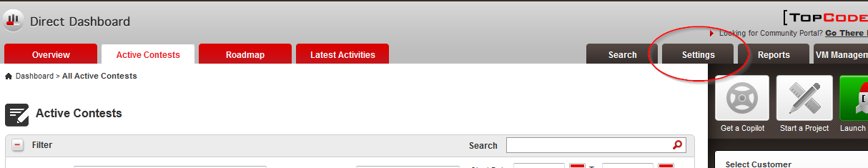

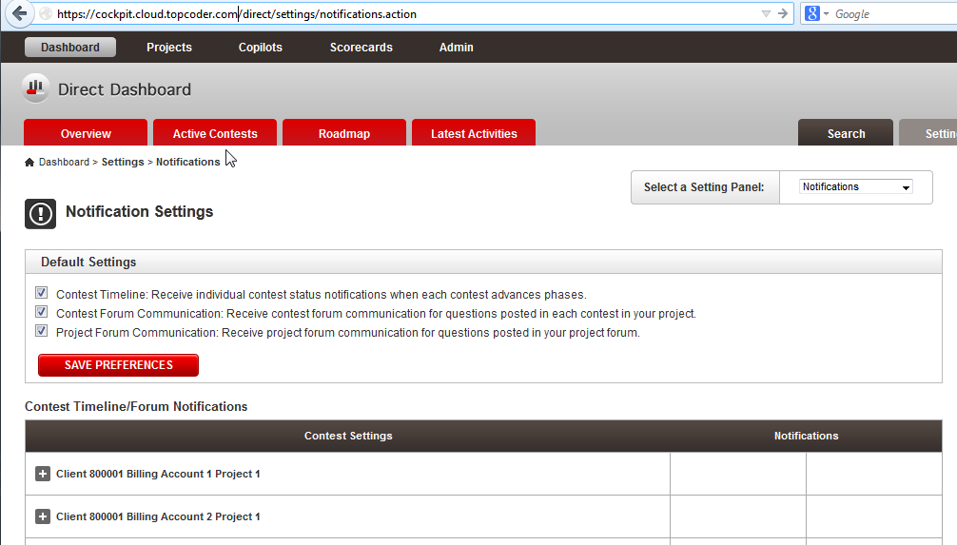

Change to the permissions setting page

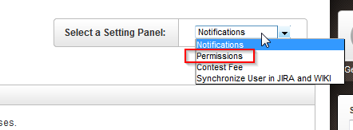

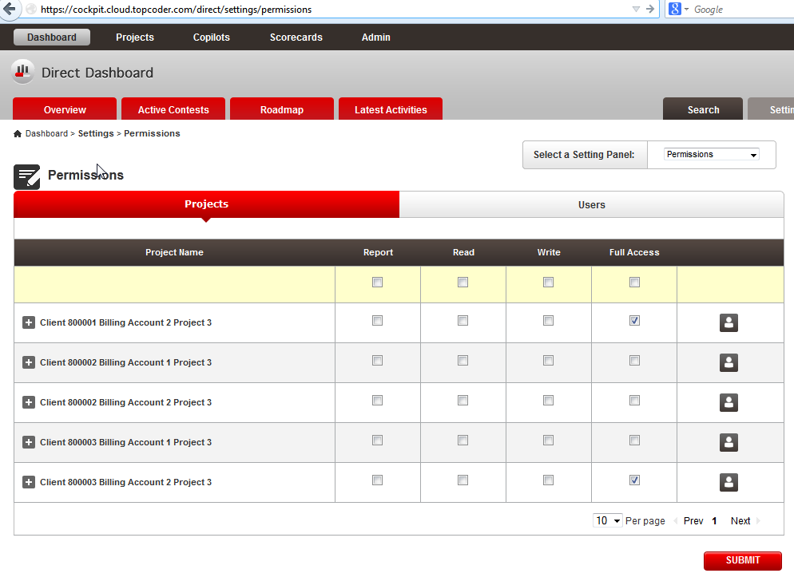

Change to the contest fee setting page

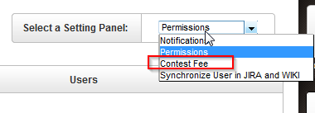

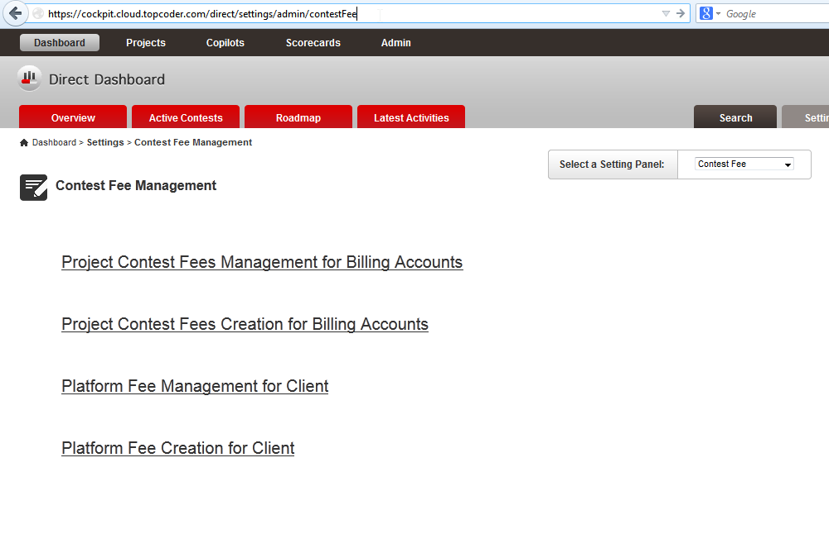

Change to sync user setting page

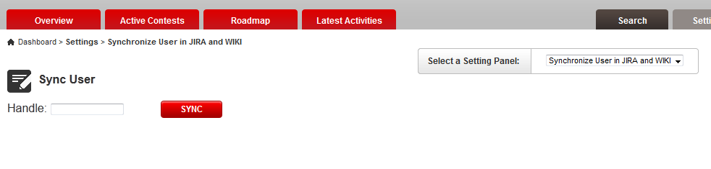

Go to any fee management page, check the bread crumb

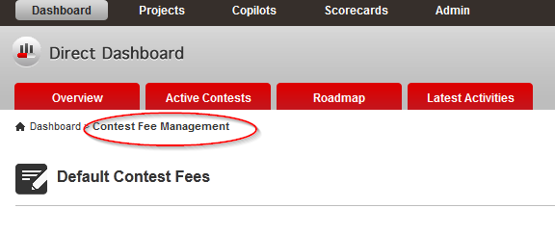

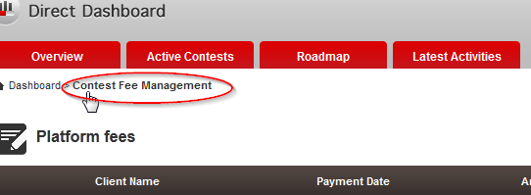

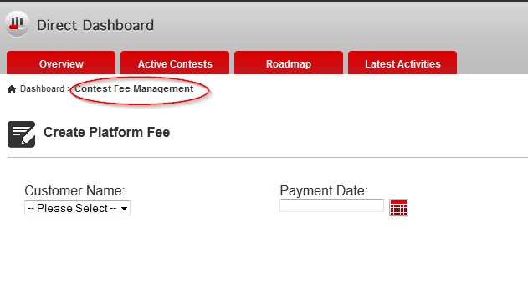

Resource Contact List

Name | Resource Email
TCSASSEMBLER

